

Business Major-Minor

Strategic Management

Course Assignment

**Starbucks Case Study**

Group Report

Student: Ying Deng 1205690

Course Number:

Teacher:

Date: 09/03/2013

**Acknowledgement**

**Abstract**

**Table of Contents**

Brief review of the company

Five forces analysis

Competitor analysis

SWOT analysis

Stakeholder analysis

Reference

**The Company**

Starbucks was established in Seattle, USA in 1971. Today, there are 17,009 stores in 50 countries such as UK, China, Mexico, NZ, Russia, Brazil etc. The number of employees is 176,000 in the world and 143,000 in US (Fiscal 2008 Annual Report, Starbucks Corporation). US accounts for approximately 70% of sales.

Starbucks product include coffee, handcraft beverage, coffee-making equipmet, fresh food, and branded products. Basic menu of beverage has 6 types which are Brewed coffee, Chocolate Beverages, Espresso Beverages, Frappuccino Blended Beverages, Kid’s Drinks and Teas, however, the rage of menu depends on the countries. For example, tastes of Sakura in Japan.

During 2004-2008, the company's revenues, grew at a CAGR of 18.3%, however the operating profit and net profit suffered a minor decline of around 4.5% and 5% respectively. The company's average return on equity and return on investment during 2002-2006 were 19%, and 18% respectively, significantly higher than the industry averages of 15.3% and 11.3%. Though it suffers the profit decline during the year 2007 and 2008 mainly because of the shut down of over half of the company-owned stores, it is still one of the most stable and fast growing companies in the year 2008[1].

As we can see from the graph, the company’s net earnings have been increasing with an average yearly percentage of 15% until 2008.

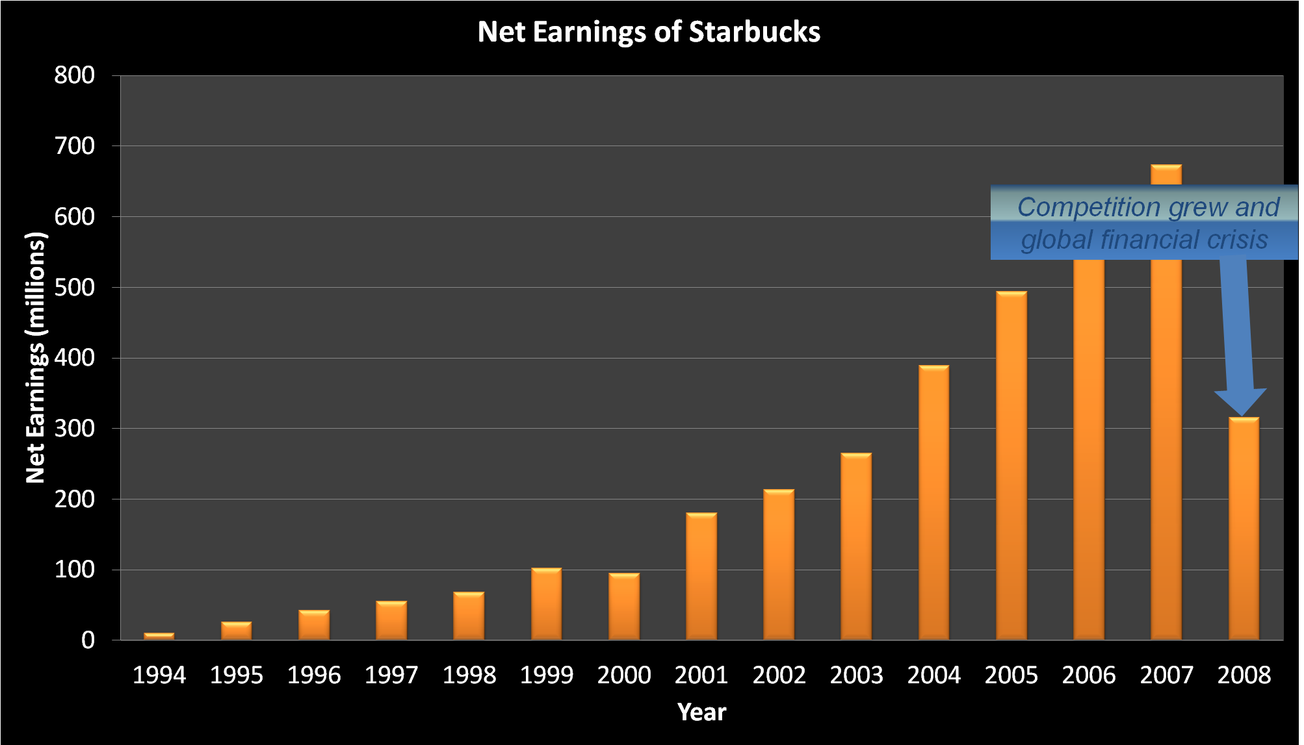

**Porter's Five Forces Analysis**

The threat of entry: low.

Starbucks is a company that have years of experience in roasting specialized coffee. It would be extremely difficult for new competitors to offer the same quality of coffee at the same competitive price. (http://www.ukessays.com/essays/marketing/starbucks-coffee.php)

The power of buyers: high.

Starbucks does face a high buyer power challenge because of the nature of the industry. The customers demanding for coffee have no switching costs to change their brand choice. This implies that the cost leadership strategy in this industry will tend to suffer severe competition and surprisingly low profit.

The power of suppliers: low.

Starbucks buy their coffee beans directly from producing countries: Latin America (50%), Pacific Rim (35%) and East Africa (15%)[2]. The company’s fixed-price and price-to-be-fixed supply chain gives it a certain level of power against suppliers.

The threat of substitutes: high.

Starbucks is facing great substitute challenges of cheaper coffee provided by competitors, and ‘coffee-at-home’ maker machines. All the instant/homemade (caffeinated) drinks such as juice, cola, water, can be a substitute threat to Starbucks.

Competitive rivalry: high.

Starbucks is mainly facing rivalry from catering establishments such as McDonalds’, which are exploring the market of premium coffee; it also has other small stores or imitators as competitors (e.g. Caribou), but they contribute less to the intensity of the competition according to the data presented. Starbucks competes with a variety of smaller scale specialty coffee shops, mostly concentrated in different regions of the country. All of these specialty coffee chains are differentiated from Starbucks in one way or another. Starbucks faces severe competition in some of the global markets, mainly from the Italian coffee store Illy and other already-well-developed local/global companies (e.g. Costa Coffee).

**Competitor analysis**

The current strategy of the company can be mainly concluded as: High margin specialty products, Franchising, Global expansion. As for the product development and market development, the main competitive forces at work can be summarized as the following.

Catering establishments (Mcdonald’s or similar catering establishments), specialist coffee chains/imitators (Calibou or similar specialty coffee store), global markets’ local competitors (Illy or similar premium coffee provider), fine coffee makers for home-made coffee (Nestle or similar instant coffee and coffee machine supplier), minor competition include other kinds of drink product suppliers.

The Strategic Group Analysis mapping can be seen as follow:

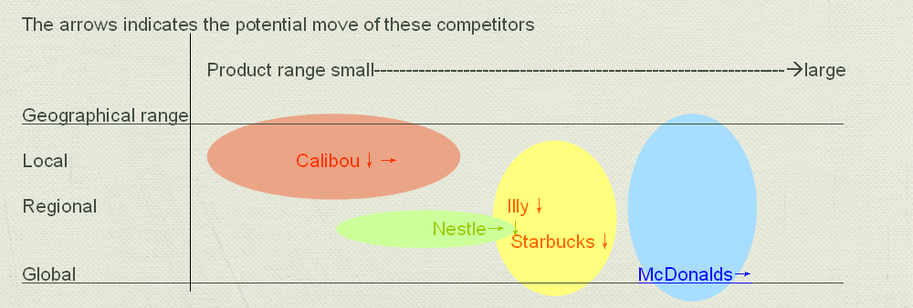

Competition is steadily growing against Starbucks each year as the industry grows. Competitors look to gain an advantage by price cuts, launching a rival product, aggressive expansion of production to increase market share or inclusion of significant modifications to a product that other competitors must also undertake to keep up[3]. At the end of 2008, Dunkin’ Donuts was close to Starbucks in number of retail stores with 8,835 stores worldwide, including 6,395 franchised restaurants in thirty-four US states and 2,240 international shops in thirty-one countries[4].





The two significant competitors in recent years will be McDonald’s and Caribou.

McDonald’s

The company will be installing coffee bars along with "baristas" who will serve cappuccinos, lattes, mochas and the Frappe, a knockoff of the Starbucks’ ice blended Frappuccino, throughout 2008 and into the beginning of 2009. The competitive threat posed by McDonald's can be summarized by referring to the February 2008 edition of the Consumer Reports magazine, which rated the McDonald's drip coffee as better tasting than Starbucks. (Adamy, McDonald's Takes on Starbucks, 2008)

Caribou coffee

Caribou Coffee is similar to Starbucks in their attempt to create a third-place. Where Starbucks strives to create an upscale European atmosphere, Caribou coffee tries to implement a more American feel to their coffee houses. They do this by modeling their coffee houses after rustic Alaskan lodges. (Quelch, 2006) Founded in 1992, Caribou coffee now operates roughly 500 stores, employs over 6000 people and grosses roughly $230 million in revenue a year. (Caribou Coffee, 2008)

**SWOT analysis**

Starbucks’ current internal position can be evaluated as this SWOT mapping:

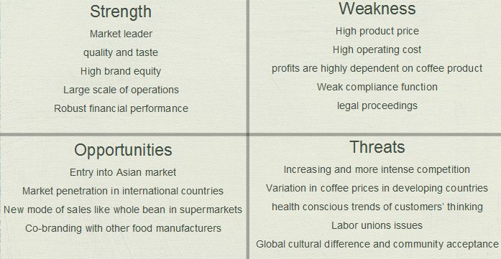

They are facing great opportunities both in the mature market of US and in the new market globally. Its robust financial performance in recent years provides it the financial backgrounds to explore new geometrical market opportunity, which we have seen remarkable growth rate of revenue of 24.0% this year (Starbucks Corporation Fiscal 2008 Annual Report). Starbuck’s good reputation of brand and product (Shultz, Pour Your Heart Into It: How Starbucks Built a Company One Cup at a Time, 1997, p. 114) gives it great power choosing co-branding or licensing partners. However, the current global economic environment and market trend of increasing competition as well as the growing consideration of healthier lifestyle[5]cast potential threats to the corporation. Starbucks high profit dependency on raw material costs and increasing product recall[6] in recent days show the corporation has its weaknesses.

**Stakeholder analysis**

It can be seen in the past few years that the stakeholder--employee/supplier/community relations can largely decide a local outlet’s sales, competition intensity, and success (Hemmati M, Dodds F, Enayti J,McHarry J, Multistakeholder Procesess on Governance and Sustainability, 2002). Stakeholder groups, such as conscious consumers, activists and investors, put major pressure on the company to live up to the high expectations concerning CSR (Du et al., 2010).

As a large corporation Starbucks draws various groups of stakeholders’ attention. The major stakeholder mapping can be seen as follow.

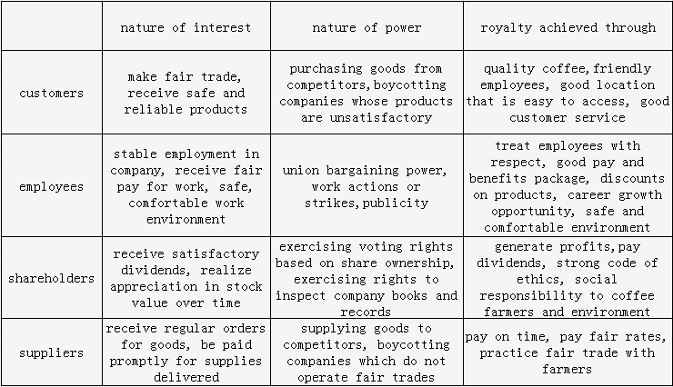

Reference

**Starbucks Annual Reports** [online],http://investor.starbucks.com/phoenix.zhtml?c=99518&p=irol-reportsAnnual

(2008, 06). **Swot Starbucks**. StudyMode.com. Retrieved 06, 2008, [online] http://www.studymode.com/essays/Swot-Starbucks-152355.html

Ross Gittell, Matt Magnusson, and Michael Merenda, **The Sustainable Business Case Book**, chapter 9.2

James Heavey, **Starbucks a Strategic Report**, 2010, [online] http://zh.scribd.com/doc/27614539/Starbucks-a-Strategic-Report-by-James-Heavey

**How to Make Healthier Lifestyle Choices**, 2012, [online] http://idiva.com/photogallery-health/how-to-make-healthier-lifestyle-choices/17088/2

**Product Recall: Starbucks Coffee Mugs -- Handle Can Break**,2007, [online] http://voices.yahoo.com/product-recall-starbucks-coffee-mugs-handle-break-697696.html?cat=7

1. (2008, 06). **Swot Starbucks**. StudyMode.com. Retrieved 06, 2008
2. James Heavey, **Starbucks a Strategic Report** (http://zh.scribd.com/doc/27614539/Starbucks-a-Strategic-Report-by-James-Heavey)
3. James Heavey, **Starbucks a Strategic Report** (http://zh.scribd.com/doc/27614539/Starbucks-a-Strategic-Report-by-James-Heavey)
4. Ross Gittell, Matt Magnusson, and Michael Merenda, **The Sustainable Business Case Book**, chapter 9.2
5. **How to Make Healthier Lifestyle Choices**, 2012 (TNN, How to Make Healthier Lifestyle Choices, 2012, http://idiva.com/photogallery-health/how-to-make-healthier-lifestyle-choices/17088/2)
6. **Product Recall: Starbucks Coffee Mugs -- Handle Can Break**,2007 (http://voices.yahoo.com/product-recall-starbucks-coffee-mugs-handle-break-697696.html?cat=7)